BCOEL Steering Committee Meeting Minutes
April 25 2022 1-2pm via Zoom

Attendance: Donna Langille (Chair), Darcye Lovsin (Notetaker), Lin Brander, Ian Linkletter, Debra Flewelling, Caroline Korbel, Amanda Grey, Karen Meijer-Klein, Ali de Haan, Caroline Daniels, Meagan Oliver, Gavin Hayes

Regrets: Lindsay (on leave), Roen Janyk (on leave), Hope Power, Reba Ouimet, Urooj Nizami, Erin Fields, Brenda Smith, Elena Kuzmina, Martin Warkentin,

Meeting Agenda

- Welcome

- Agenda: Changes and additions

- Approval of the March 21, 2022 meeting minutes

- Two new members

  - Meagan Oliver - University Canada West
  - Gavin Hayes - University Canada West
    - Action Item: Darcye – add new members to website - done

- March Action Items
  - OER Commons Working Group – Darcye organized the first meeting – if anyone is still interested in joining the working group, please contact Darcye
  - Adding OER to catalogue - Lin has update in agenda
  - Invite cataloguers to meeting – Coming to next meeting (May)
  - Logo - on agenda
  - Setup meeting with KPU/TRU re: ZTC and registration systems – Debra met with TRU and ZTC

- Determining what open content to add to catalogues – update (please see listserv email from April 1) and next steps (Lin)
  - A few different options
  - Too overwhelming to go over every single title – possible to look at different open collections and choose which to include in collections
  - Is this something that would be useful provincially? A few options:
    - One time project – Joint look at all open content available through the different library systems – give feedback and suggestions
    - Create space for libraries to post about problem items – libraries identify individually and report
  - KPU has identified issues with the open list in Summons
    - Does not put open collections in catalogue
    - Plan to assess lists in general (not individual titles)
    - Would be helpful if there was a standard criteria for assessing and to split up the lists
      - Suggestion – criteria similar to the rubric for evaluating OER repositories? https://bcoel.ca/wp-content/uploads/2018/11/oerr-rubric-2018.pdf
    - Took down open indicator in Summons because student feedback was that some items lead to a paywall
  - Adding open collections to catalogue might overwhelm results and suppress
  - Location/resource in BCOEL OER Repository where institutions could flag collections that are problematic
    - Group decided to table the discussion for the Fall

Action Item – Darcye add to OER Commons working group to explore editable documents

- Non-con update (Lin)
  - Open event at BCIT where people sign up to speak briefly (15-min) about a teaching and learning topic (doesn’t have to be open)
  - Would BCOEL like to join in the BCIT non-con?
  - At the beginning of organizing – probably will take place in June
  - Encourage anyone to participate – just sign up
  - Related to learning and teaching – could share about open or another topic

- BCOEL Logo – update from BCcampus and next steps (Donna)
  - Vote on new logo (three options sent around by Donna with agenda items)

Action item (Everyone) – email Donna your top choice of the logos below. Please describe which logo you prefer or copy the logo into the email.

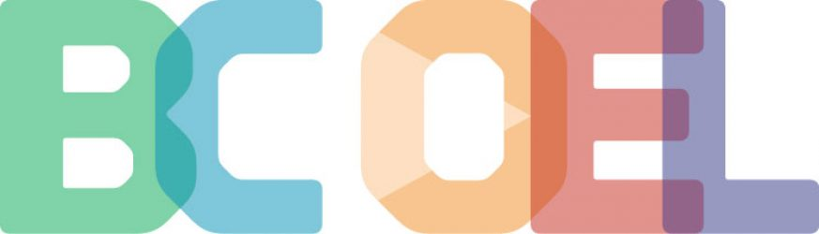

- Meeting with Linda, Cleire, and Lauri to talk about metadata available on ancillary resources in BCCampus Open Textbook Collection – update (Donna)
  - Attending May meeting

- Course Marking/ZTC 2 Part Event
  - March meeting people had interest in learning how other institutions mark ZTC courses during registration
  - Ran out of time to discuss
  - Douglas – putting ZTC attribute in Banner on courses that are adopted by all faculty for that course (instead of adding it to individual sections)
    - Bulk of adoptions are course wide
    - Adding attribute two semesters in advance
  - Invite wider BCOEL listserv to a discussion with institutions have already implemented (similar to Pressbooks discussion a few years ago)
    - Less formal than an event
  - KPU – Amanda and Urooj
  - Doulas – Debra
  - TRU – Brenda
  - UCW – Meaghan - mark in academic calendar which courses use open textbooks
  - Open Education Cross-Canada Coffee Chat – possible topic for future event?
    - Wednesday’s event: https://www.carl-abrc.ca/mini-site-page/join-us-for-the-april-open-education-cross-canada-coffee-chat-oecccc/

Action Item – Debra will contact CARL organizers to suggest this as a topic.
- Donna with contact Amanda, Urooj, Debra, Brenda, Meaghan about the discussion/event

- Roundtable
  - JIBC – starting open ed strat plan for CTLI and Library
  - KPU – ZTC data visualizations from the past three years: https://www.kpu.ca/open/ztc
    - Plan to add data each semester moving forward
    - Data comes from marking open courses in Banner

- Adjournment at 1:42 – Next meeting on May 16th at 1:00pm

